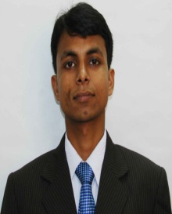
CURRICULUM-VITAE
SUNNY KUMAR SINGH

Specialization
Major – Marketing
Minor – Finance

Academic Qualifications
Degree | Institute/ University | Discipline | Year of Passing | % Aggregate
MBA | EIILM | Marketing/Finance | 2015 | 64.05%
Graduation | Rajendra College  Jai Prakash university | B.Com  (Accountancy) | 2012 | 65.13%
Higher Secondary | Jaintpur Public School  (CBSE) | Commerce | 2009 | 64.00%
Secondary | Jaintpur Public School  (CBSE) | General | 2007 | 63.20%

Projects Undertaken
External Project
- Project Title – Study of consumer behavior in the retail outlet of FMCD in Sony India
- Organization – Sony India
- Duration – 2 months

Internal Projects
  - Project Title – CSR Project on under privilege students
  - Duration - 1 Month

Professional Attainment
- Industrial visit to Anmol Biscuits

Co-Curricular Activities
- Completed Computer Applications “O” level from Doeacc Society

Interests
- Listening music
- Playing Chess
- Watching Movies

Personal
- Date of Birth :25th January1992
- Guardian’s name : Seema Singh
- Languages Known :English, Hindi

Permanent Address
Address:- North Dahiyava Tola ,Chapra ,Saran .Pin-841301
Residence No :-(06152) 240075
Mobile : - 8961023168
Email ID : sunnyku1992@gmail.com

Present Address
Address:-2/1B/2 ,Ashok Nagar Tollygunge, Kolkata-700040

DATE:
PLACE : SIGNATURE OF THE STUDENT

